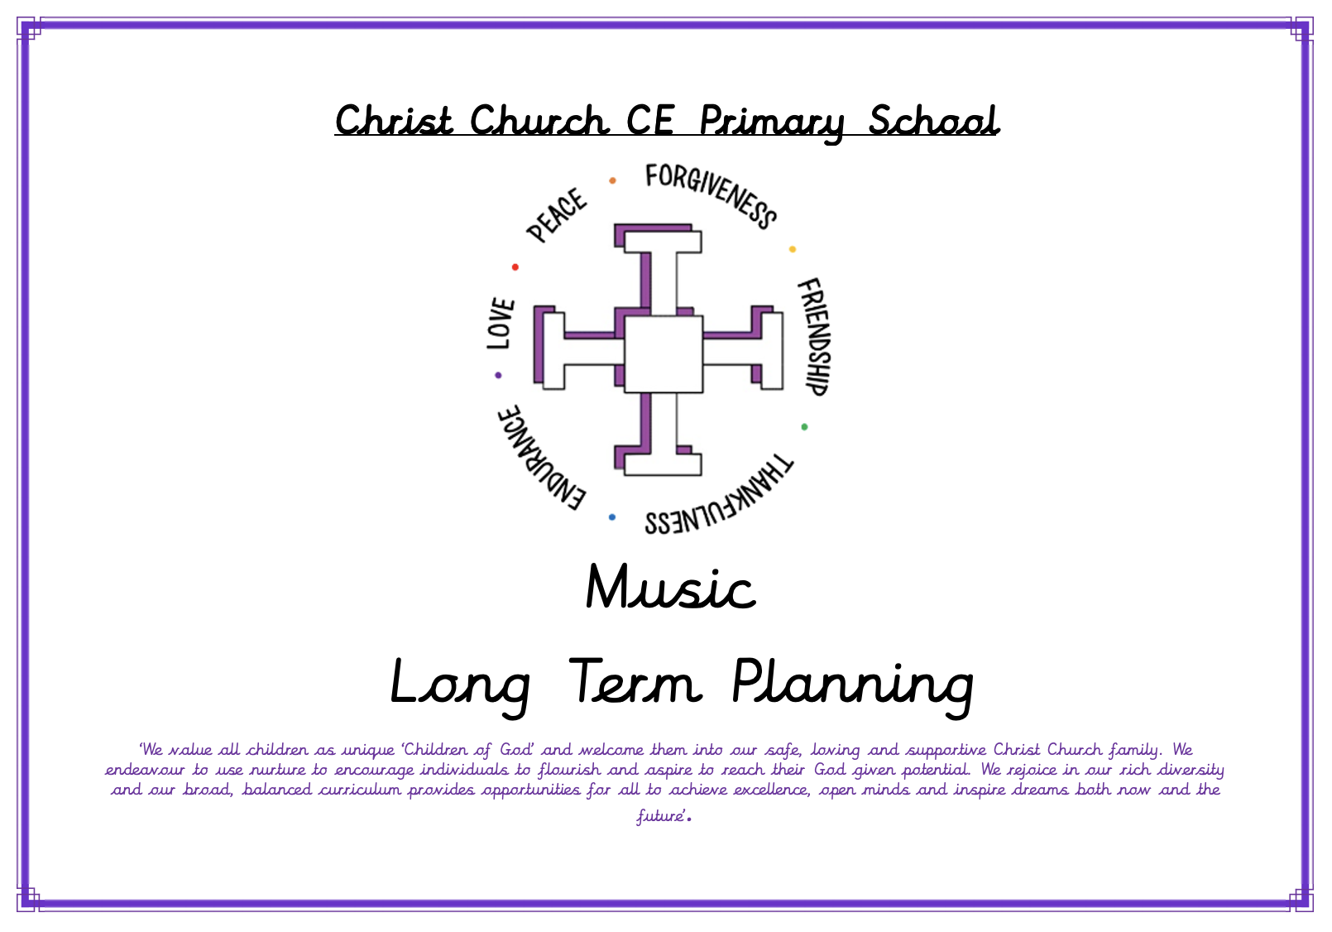
Christ Church CE Primary School

Music
Long Term Planning
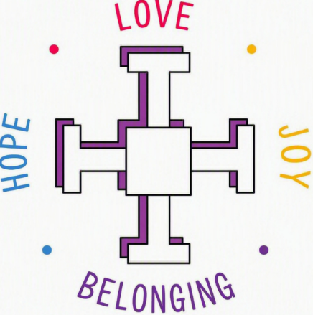
 | Autumn 1 | Autumn 2 | Spring 1 | Spring 2 | Summer 1 | Summer 2
EYFS: Reception | Exploring sound | Celebration music | Music and movement | Musical stories | Transport | Big band
Year 1 | My favourite things: Keeping the pulse | Snail and mouse: Tempo | Seaside: Dynamics | Fairytales: Sound patterns | Superheroes: Pitch | Under the sea: Musical symbols
Year 2 | Animals: Call and response | Musical storytelling: Instruments | Space: Contrasting dynamics | On this island: Singing | Myths and legends: Structure | Musical me: Pitch
Year 3 | Mountain melodies: Steps and leaps | Reading rhythms: Patterns and layers | Inspired by India: Musical improvisations | Music technology: Introduction to music technology | Reggae rhythms: Playing in a band | Baroque meets pop: Building harmony
Year 4 | Singing in parts: Loops and layers | Musical motifs: Reading the stave | Sounds of China: Scales and structure | Music technology: Loop-based composition | 12-bar blues: Playing in a band | Minimalist melodies: Developing patterns
Year 5 | Music in nature: Chords and melodies | Three-chord pop: Playing in a band | West African rhythms: Create, play and perform | Music technology: Composing for games | Stage and song: Storytelling through music | Samba sounds: Rhythm and groove
Year 6 | Four-chord pop: Playing in a band | Songs that speak: Lyrics and messages | Bhangra beats: Global grooves | Music technology: Film soundtracks | Theme and variations: Developing melodies | Leavers: Our story in song
Topic Overviews (All year groups)

KS1: Year One Curriculum Overview
Autumn 1 | Autumn 2 | Spring 1 | Spring 2 | Summer 1 | Summer 2
My Favourite Things  Keeping Pulse and Rhythm | Snail and mouse  Tempo | Seaside  Dynamics | Fairytales  Sound Patterns | Superheroes  Pitch and Tempo | Under the sea  Musical Symbols
Key Vocabulary | Key Vocabulary | Key Vocabulary | Key Vocabulary | Key Vocabulary | Key Vocabulary
- pulse  - singing voice  - speaking voice  - voice | - fast  - instrument  - pulse  - singing voice  - slow  - speaking voice  - voice | - instrument  - loud  - quiet  - symbol  - volume | - feeling  - instrument  - loud  - pulse  - quiet  - sound  - voice | - fast  - high  - low  - pattern  - perform  - slow | - fast  - high  - loud  - low  - pulse  - quiet  - slow  - sound  - symbol  - volume

KS1: Year Two Curriculum Overview
Autumn 1 | Autumn 2 | Spring 1 | Spring 2 | Summer 1 | Summer 2
Animals:  Call and response | Musical storytelling:  Instruments | Space  Dynamics | On this island:  Singing | Myths and legends:  Structure | Musical me:  Pitch
Key Vocabulary | Key Vocabulary | Key Vocabulary | Key Vocabulary | Key Vocabulary | Key Vocabulary
- call and response  - louder  - pattern  - perform  - quieter | - faster  - feeling  - instrument (Y1)  - louder  - perform  - quieter  - slower  - sound effect | - choose  - compose  - faster  - higher  - louder  - lower  - pattern  - pitch  - quieter  - slower  - symbol | - compose  - higher  - idea  - lower  - perform  - pitch  - symbol  - voice | - beat  - choose  - compose  - faster  - half beat  - one beat  - pattern  - perform  - rhythm  - slower  - symbol | - beater  - grip  - higher  - lower  - note  - pattern  - pitch  - symbol

LKS2: Year Three Curriculum Overview
Autumn 1 | Autumn 2 | Spring 1 | Spring 2 | Summer 1 | Summer 2
Mountain melodies:  Steps and leaps | Reading rhythms:  Patterns and layers | Inspired by India:  Musical improvisations | Music technology:  Introduction to music technology | Reggae rhythms:  Playing in a band | Baroque meets pop:  Building harmony
Key Vocabulary | Key Vocabulary | Key Vocabulary | Key Vocabulary | Key Vocabulary | Key Vocabulary
- beater  - grip  - higher  - lower  - note  - pattern  - pitch  - symbol | - beater  - grip  - higher  - lower  - note  - pattern  - pitch  - symbol | - beater  - grip  - higher  - lower  - note  - pattern  - pitch  - symbol |  | - beater  - grip  - higher  - lower  - note  - pattern  - pitch  - symbol

LKS2: Year Four Curriculum Overview
Autumn 1 | Autumn 2 | Spring 1 | Spring 2 | Summer 1 | Summer 2
Singing in parts:  Loops and layers | Musical motifs:  Reading the stave | Sounds of China:  Scales and structure | Music technology:  Loop-based composition | 12-bar blues:  Playing in a band | Minimalist melodies:  Developing patterns
Key Vocabulary | Key Vocabulary | Key Vocabulary | Key Vocabulary | Key Vocabulary | Key Vocabulary
- beater  - grip  - higher  - lower  - note  - pattern  - pitch  - symbol | - compose (Y1/2)  - composition  - focus  - higher (Y2)  - lower (Y2)  - motif  - mood  - note (Y2)  - pattern (Y1/2)  - perform (Y1/2)  - pitch (Y2)  - pitch notation  - play (Y1/2)  - practise  - repeat  - stave | - compose (Y4)  - dynamics (Y3)  - melody (Y3)  - musical contrast (Y3)  - pentatonic scale (Y3)  - rhythmic loop (Y4)  - structure (Y3)  - tempo (Y4)

UPKS2: Year Five Curriculum Overview
Autumn 1 | Autumn 2 | Spring 1 | Spring 2 | Summer 1 | Summer 2
Music in nature:  Chords and melodies | Three-chord pop:  Playing in a band | West African rhythms:  Create, play and perform | Music technology:  Comping for games | Stage and song:  Storytelling through music | Samba sounds:  Rhythm and groove
Key Vocabulary | Key Vocabulary | Key Vocabulary | Key Vocabulary | Key Vocabulary | Key Vocabulary
- compose (Y4)  - dynamics (Y3)  - melody (Y3)  - musical contrast (Y3)  - pentatonic scale (Y3)  - rhythmic loop (Y4)  - structure (Y3)  - tempo (Y4) | - compose (Y4)  - dynamics (Y3)  - melody (Y3)  - musical contrast (Y3)  - pentatonic scale (Y3)  - rhythmic loop (Y4)  - structure (Y3)  - tempo (Y4)

UKS2: Year Six Curriculum Overview
Autumn 1 | Autumn 2 | Spring 1 | Spring 2 | Summer 1 | Summer 2
Four-chord pop:  Playing in a band | Songs that speak:  Lyrics and messages | Bhangra beats:  Global grooves | Music technology:  Film soundtracks | Theme and variations:  Developing melodies | Leavers:  Our story in song
Key Vocabulary | Key Vocabulary | Key Vocabulary | Key Vocabulary | Key Vocabulary | Key Vocabulary
- bass line (Y3)  - breath control  - build-up  - chord (Y3)  - confidence (Y3/4)  - control (Y3/4)  - create  - focus (Y3/4)  - harmony (Y3/4)  - in time (Y3/4)  - introduction (Y3/4)  - leader (Y3/4)  - lyrics  - melody (Y3)  - mood (Y3/4)  - non-verbal cue  - pop  - posture (Y3/4)  - practise (Y3/4)  - rehearse  - repeat (Y3/4)  - stage awareness  - stave (Y3/4)  - structure (Y3)  - technique (Y3/4)  - tempo (Y4)  - unison | - 4/4 time (Y5)  - accented beat  - accompaniment  - bar  - chord (Y3)  - chord sequence (Y5)  - chorus (Y5)  - confidence (Y3/4)  - control (Y3/4)  - create  - expression  - in time (Y3/4)  - leader (Y3/4)  - lyrics  - melody (Y3)  - mistakes  - mood (Y3/4)  - non-verbal cue  - perform (Y1/2)  - practise (Y3/4)  - rehearse  - repeat (Y3/4)  - stage awareness  - structure (Y3)  - theme  - verse (Y5) |  |  |  | - allegro  - arrangement  - backing track  - chorus  - chord progression  - compose  - crescendo  - diminuendo  - dynamics  - evaluate  - forte  - largo

